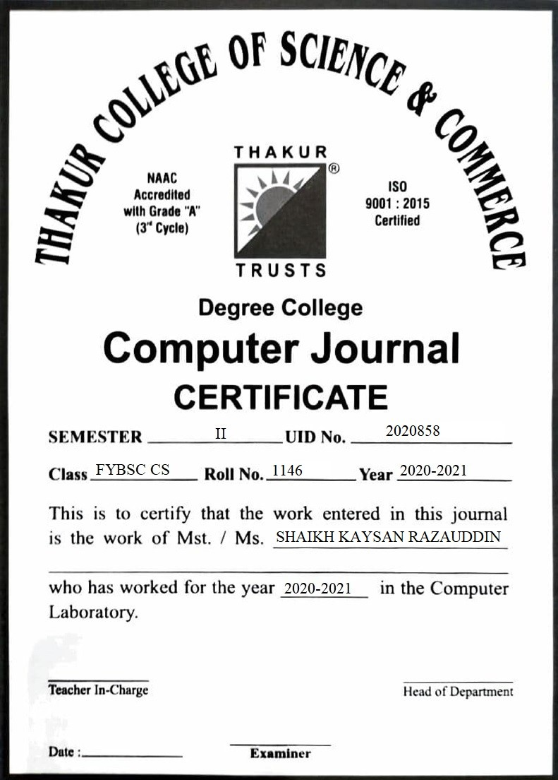

INDEX

|  |  |  |  |
| --- | --- | --- | --- |
| **Sr.**  **No.** | **Title** | **Date** | **Pg.**  **No** |
| 1 | Linux Installation | 22/02/21 | 3 |
| 2 | Screen resolution, Networking, Time settings | 01/03/21 | 7 |
| 3 | Installing and Removing Software | 08/03/21 | 12 |
| 4 | Documentations | 15/03/21 | 14 |
| 5 | Command Line Operations | 22/03/21 | 21 |
| 6 | File Operations | 05/04/21 | 28 |
| 7 | Use Environment | 12/04/21 | 33 |
| 8 | Linux Editors: Nano/vim/gedit | 19/04/21 | 38 |

Practical No:01

**Aim:** Linux Installation.

a) Install your choice of Linux distribution e.g. Ubuntu, Fedora, Debian.

Installing Zorin Operating System:

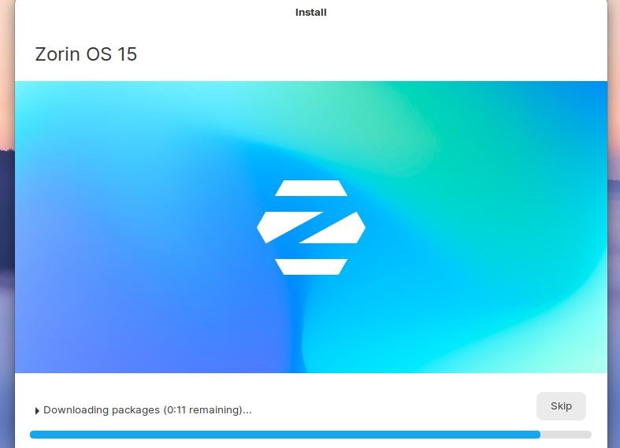

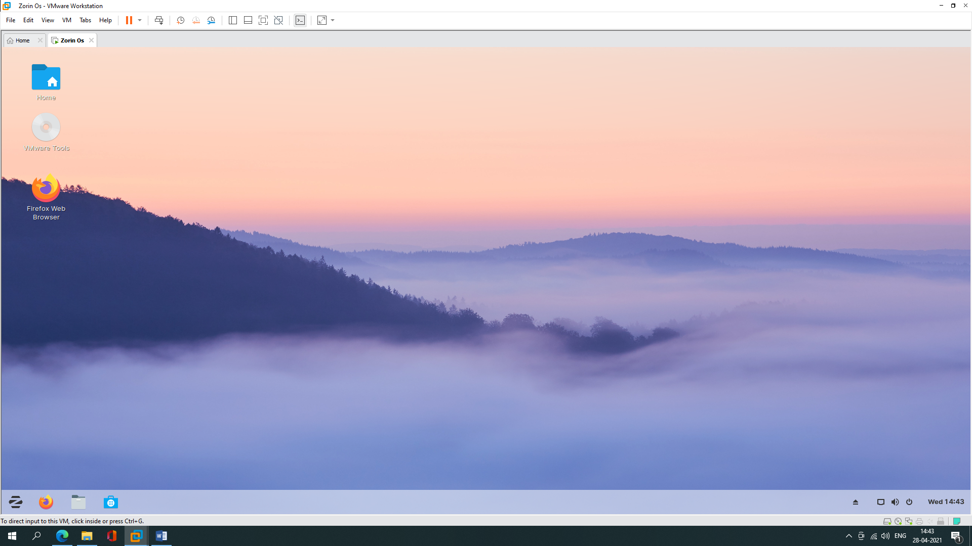

b) Customize desktop environment by changing different default options like changing default background, themes.

**Changing background**

**Go to settings, click on ‘appearance’ and select the option wallpaper, now you can choose any wallpaper you want to set in background.**

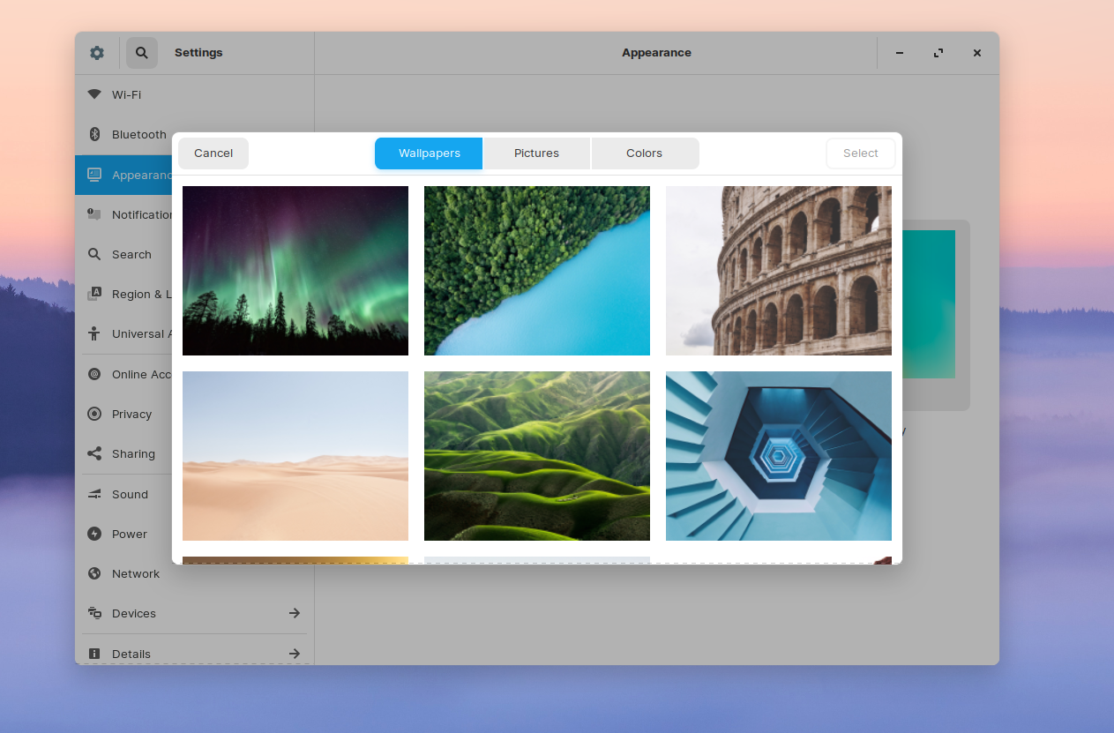

**After Changing Background**



**Changing theme**

**Go to settings and click on ‘Appearance’, click on the option zorin appearance.**

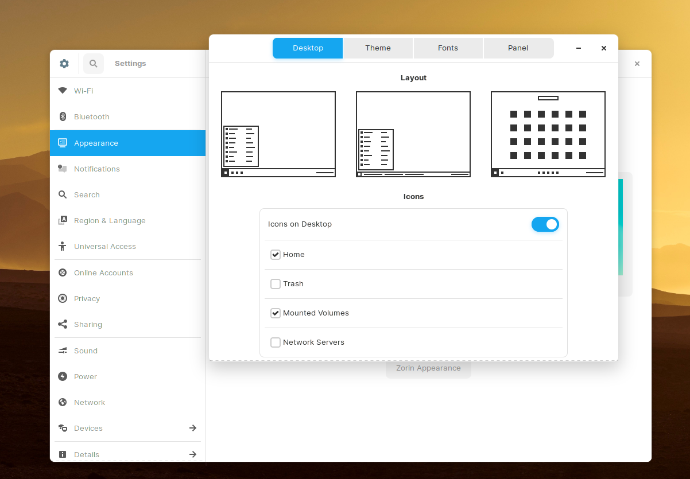

**Select the option theme and pick the theme you wanted.**

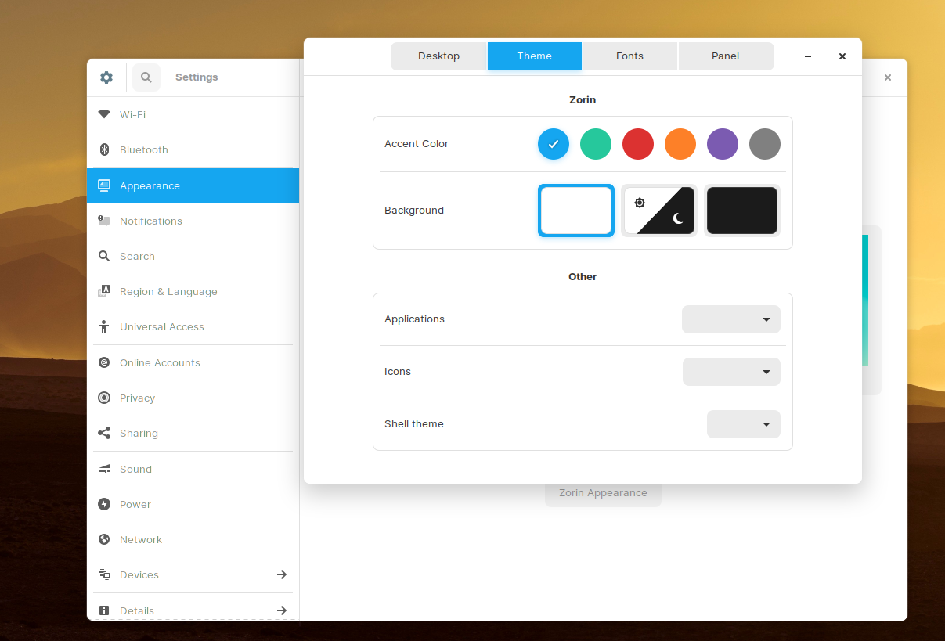

**After Changing the theme.**

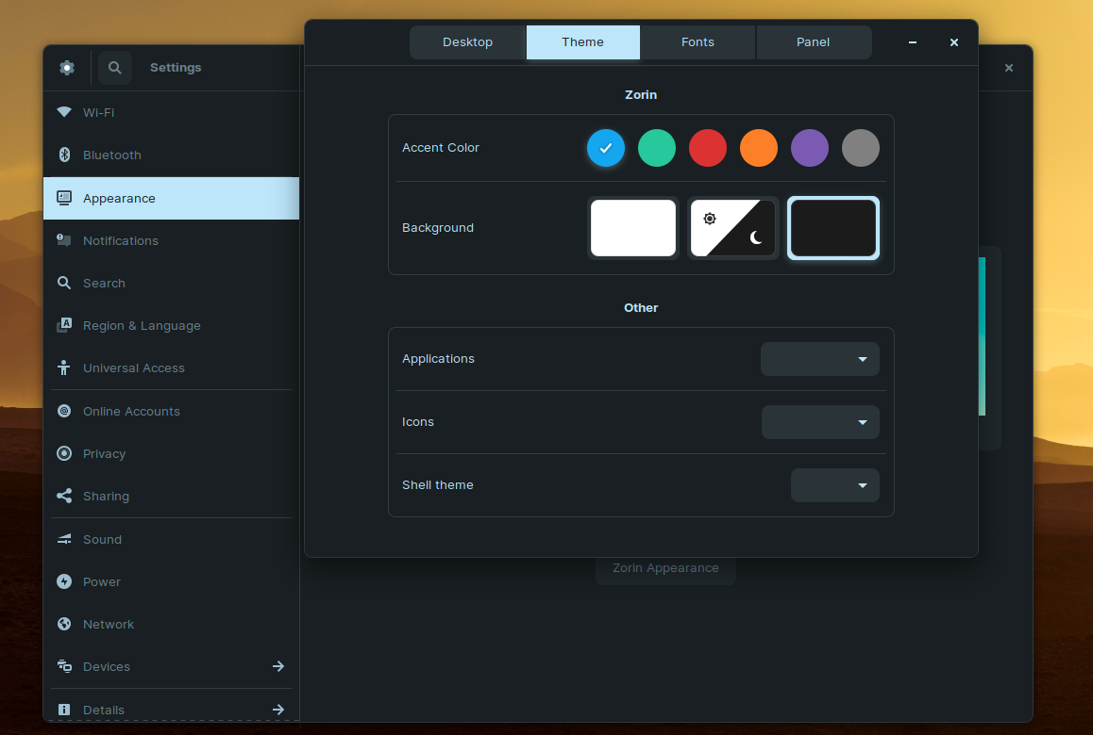

Practical No:02

**Aim:** Screen Resolution, Networking, Time Settings.

1. Screen Resolution: Ascertain the current screen resolution for your desktop.

**Go to setting and click on ‘Displays’ and under resolution choose the one that suits you.**

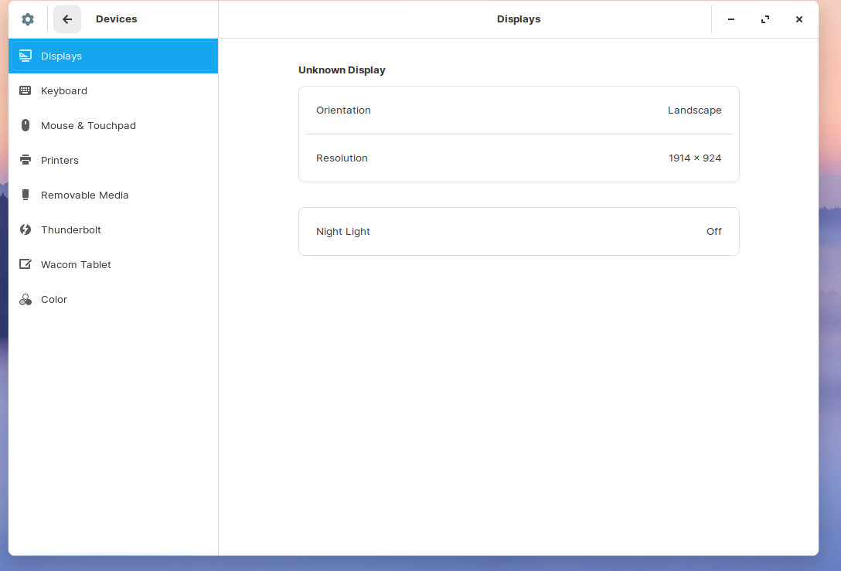

**After changing the resolution**.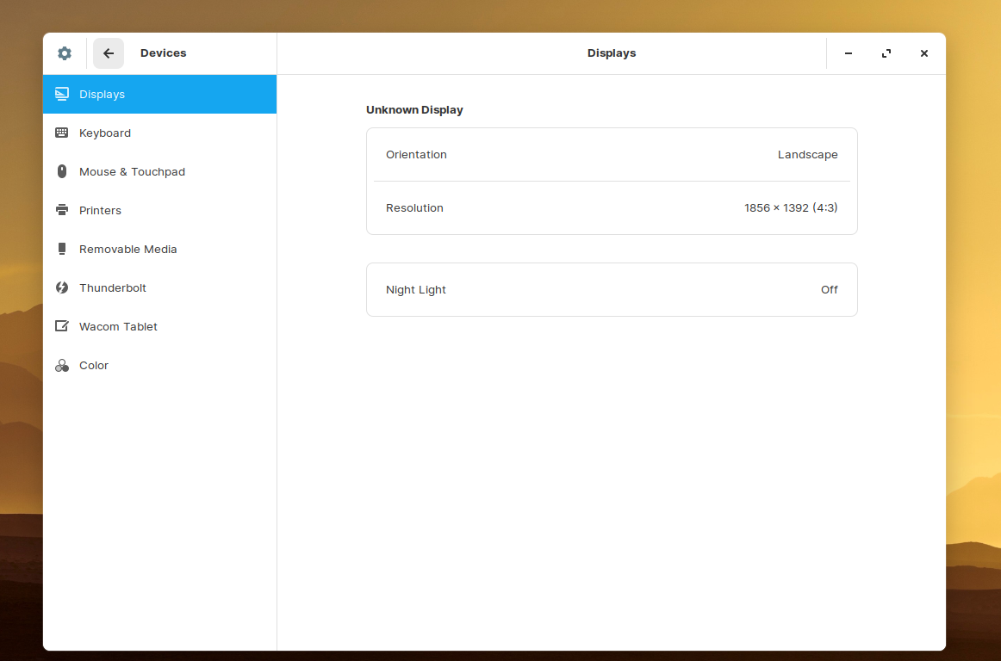

b) Networking: Get the current networking configuration for your desktop.

Are you on a wired or a wireless connection? What wireless connections are available, if any?

**Using GUI**

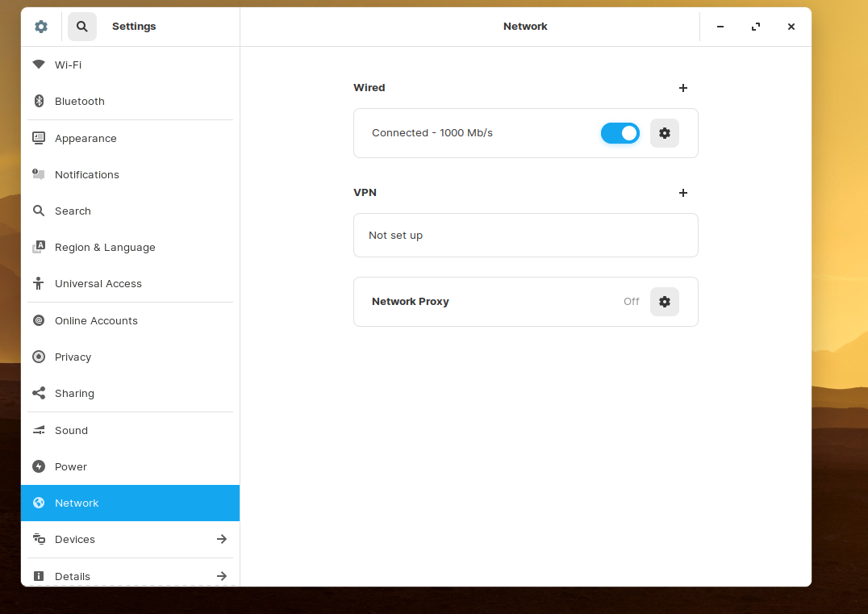

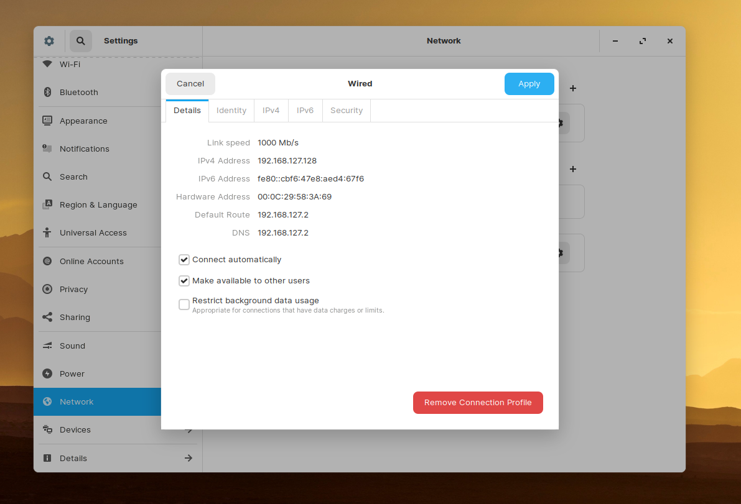

**Using CMD**

**Type ifconfig command, if the command is not found you can install with by using command ‘sudo apt install net -tools’.**

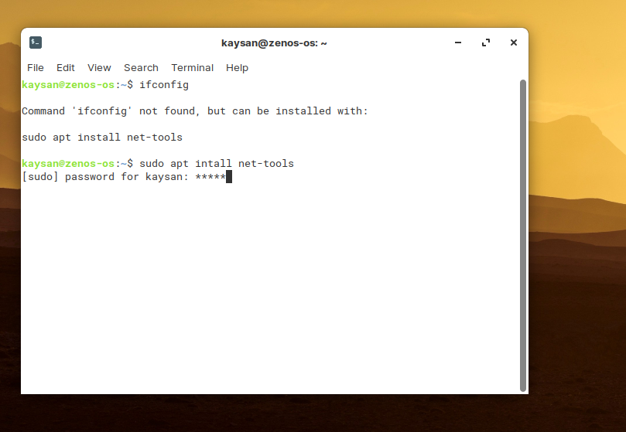

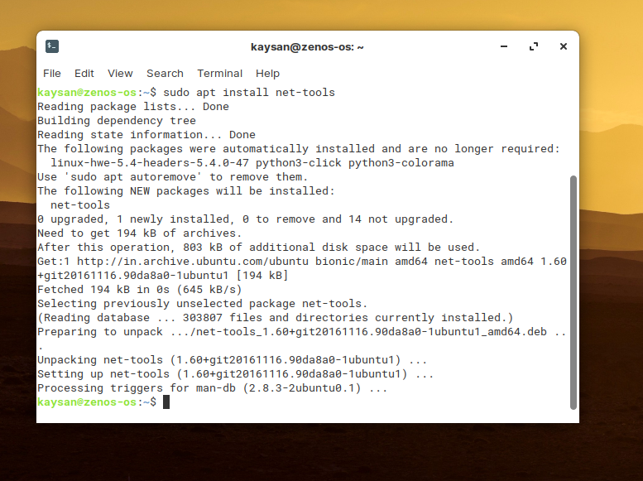

**After Using ifconfig.**

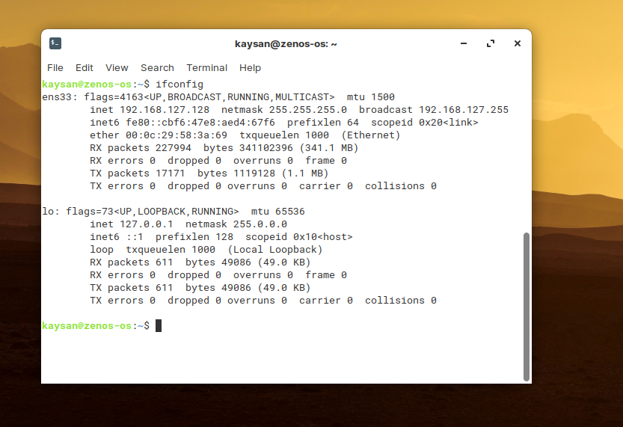

c) Time settings: Change the time zone of your system. After noting the time change, change the time zone back to your local time zone.

**Go to settings and click on ‘Date & Time’.**

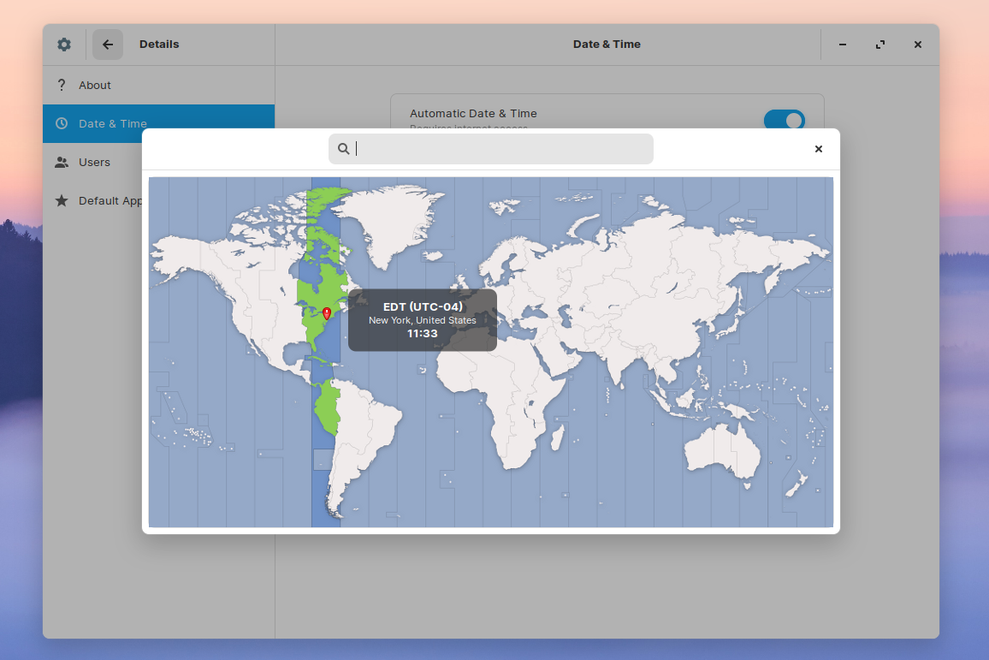

**After changing time zone.**

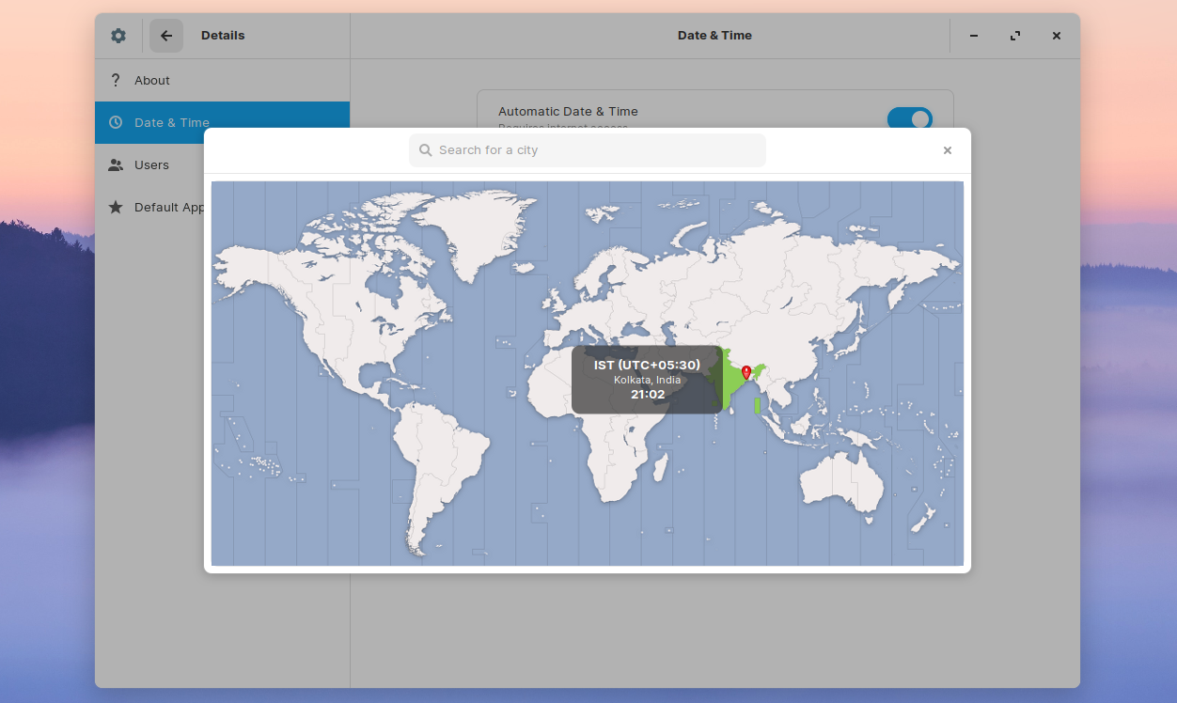

Practical No:03

**Aim:** Installing and Removing Software: Install a gcc Package. Verify that it runs and then remove it.

**Installation of gcc package.**

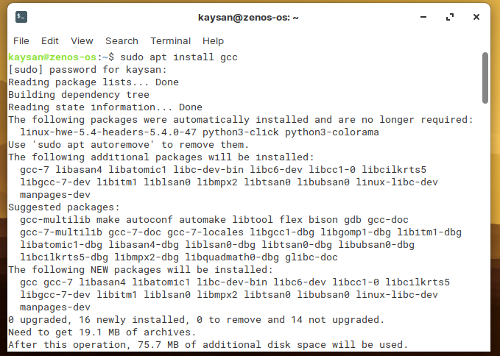

**To check whether its working or not , we check the gcc version by using simple command gcc --version.**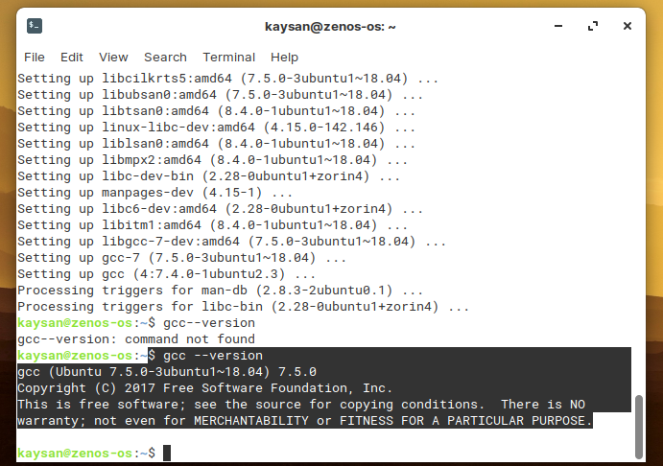

**Uninstalling the package.**

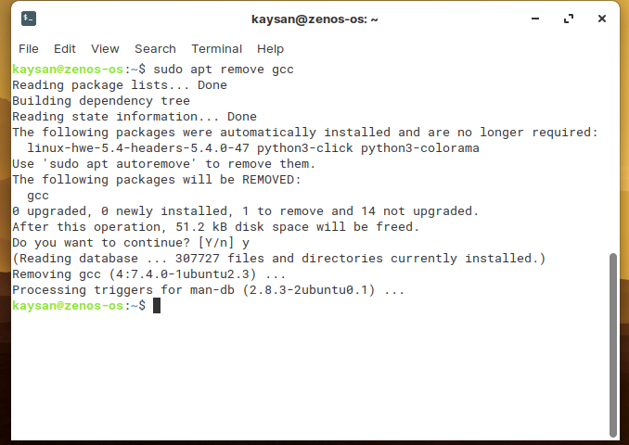

Practical No:04

**Aim:** Documentations:

1. Finding info Documentation: From command line: Bring up the info page for the grep command. Bring up the usage section.

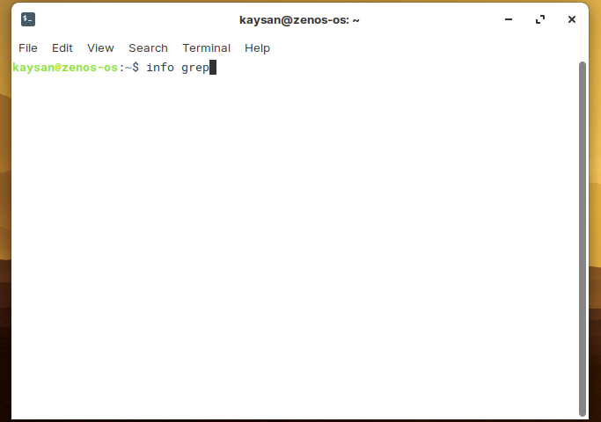

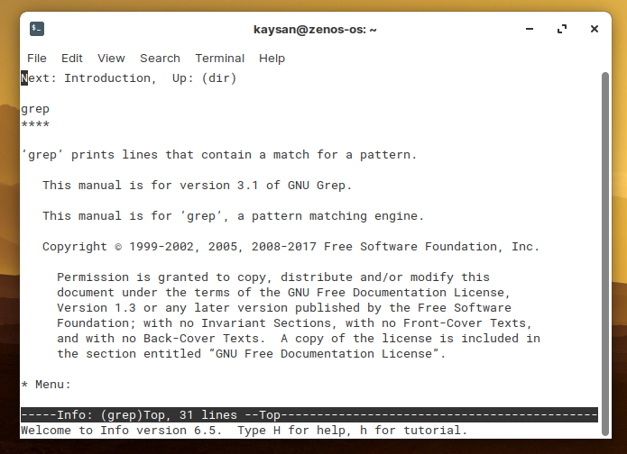

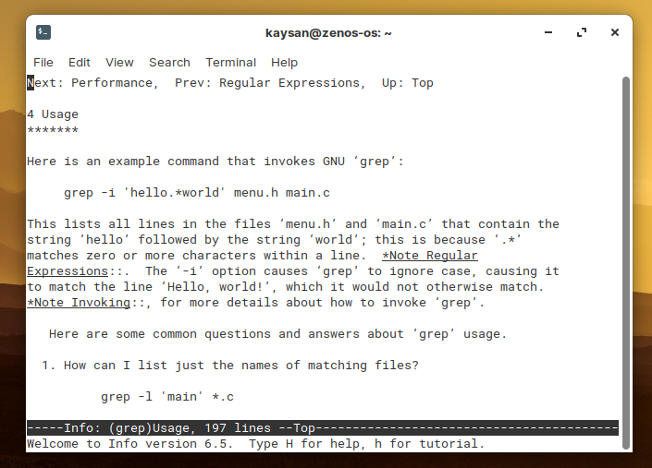

b) Finding man pages from cmd: Bring up the man page for the ‘ls’ Command.

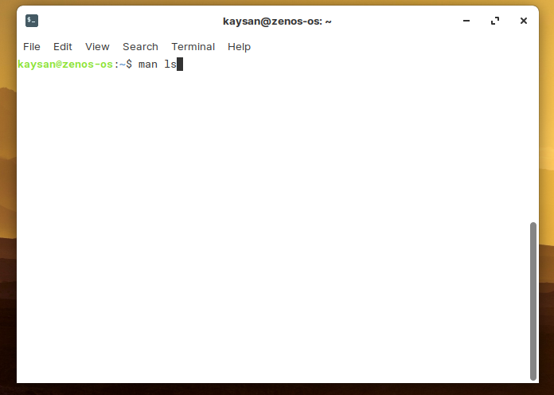

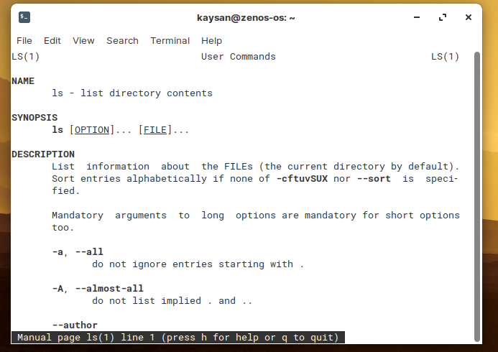

c) Finding man pages by topic: What man pages are available that document file compression?

**Commands:**

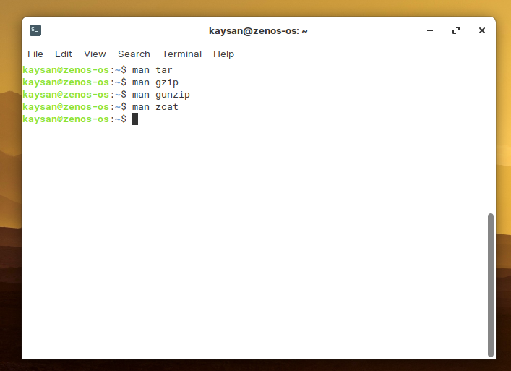

**Command: man tar.**

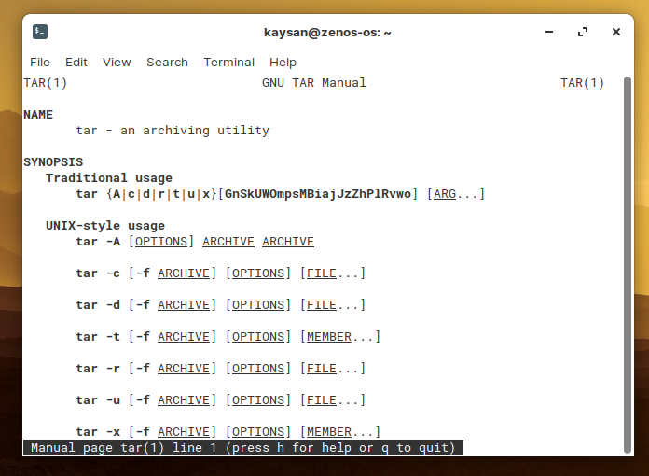

**Command: man gzip, man gunzip, man zcat.**

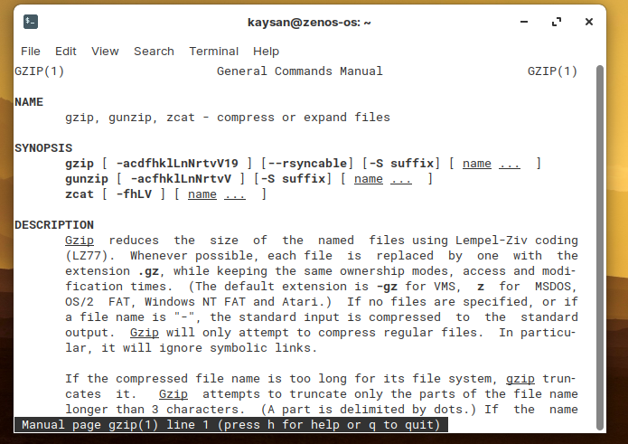

d) Finding man pages by Section From the command line, bring up the man page for the printf library function. Which manual page section are library functions found?

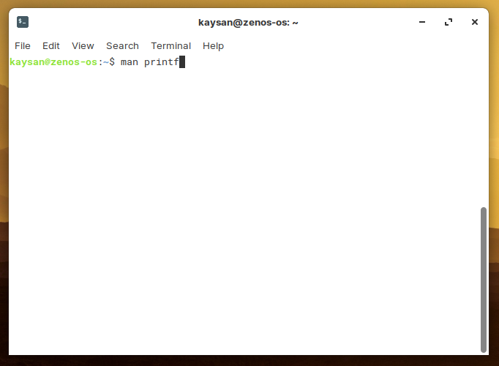

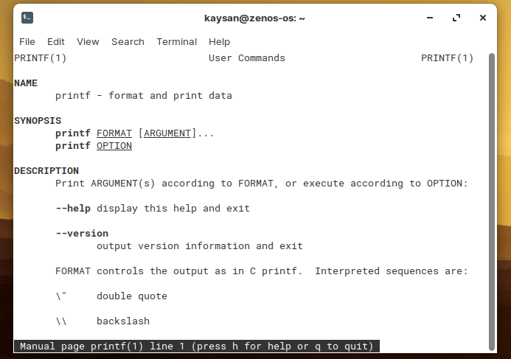

e) Command-Line Help List the available options for the mkdir command. How can you do  
this?

**Use mkdir –help command**

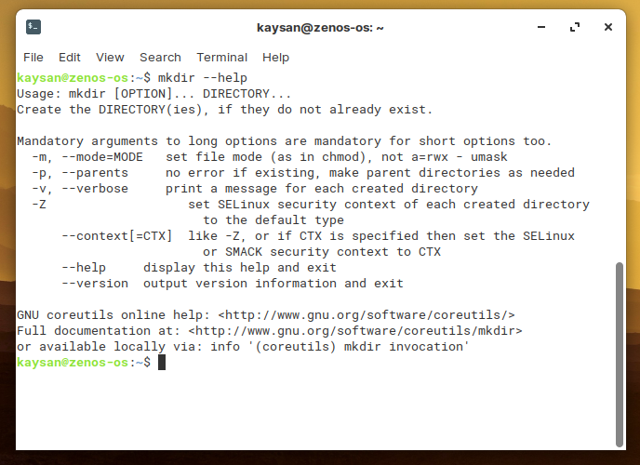

Practical No:05

**Aim:** Command line operations:

1. Install any new package on your system.

**Installing python3 from terminal:**

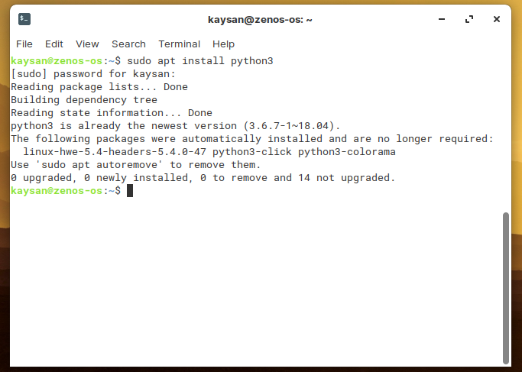

b) Remove the package installed.

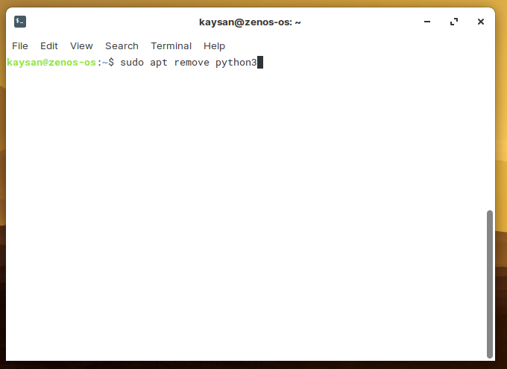

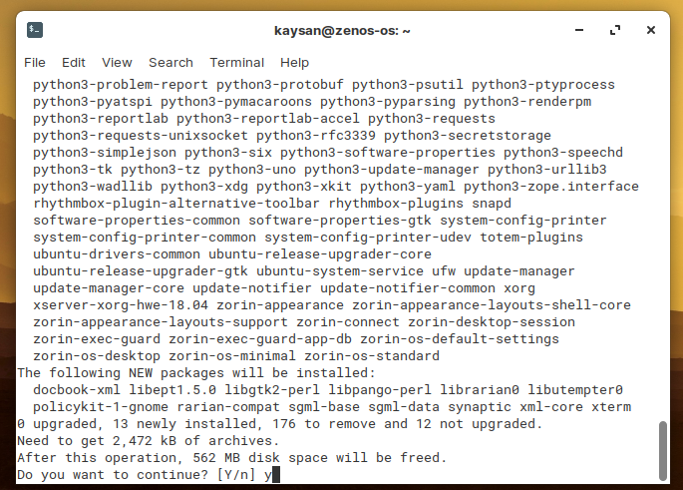

c) Find the passwd file in / using find command.

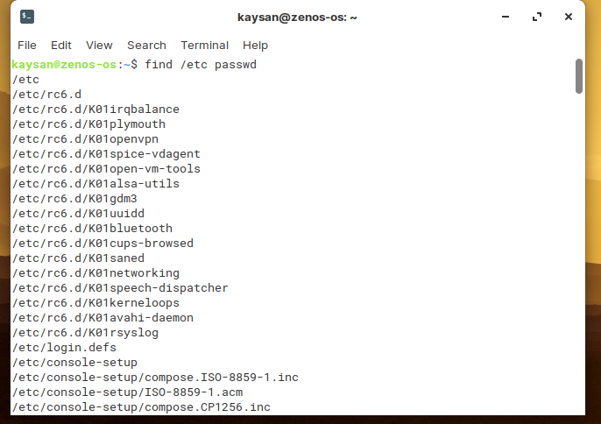

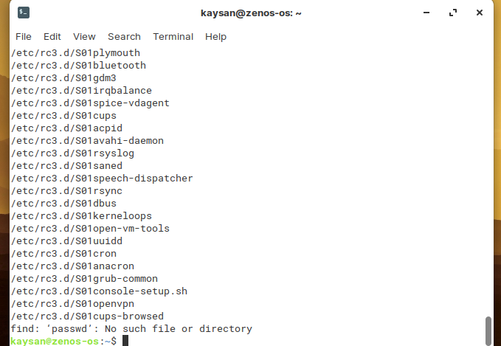

d) Create a symbolic link to file.

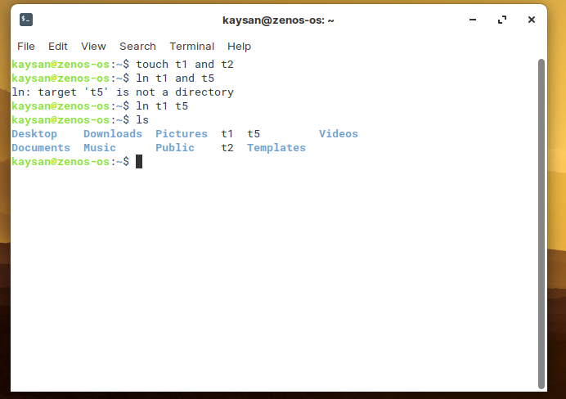

e) Create an empty file example.txt and move it in /tmp directory using relative path name.

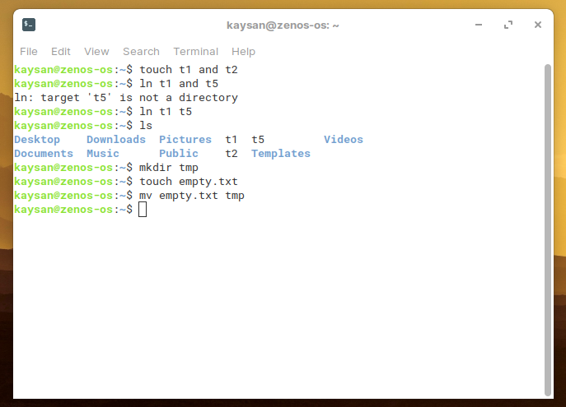

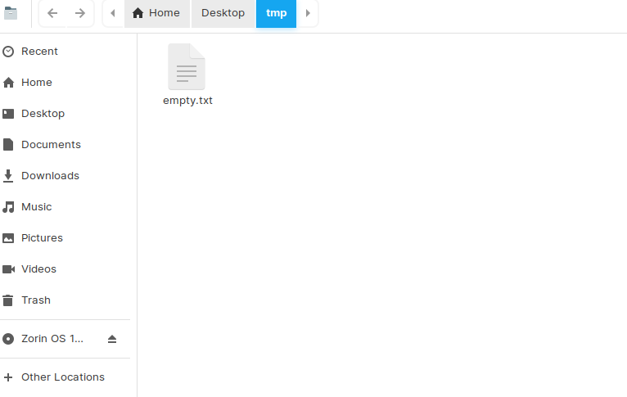

f) Delete the file moved to /tmp in previous step using absolute path.

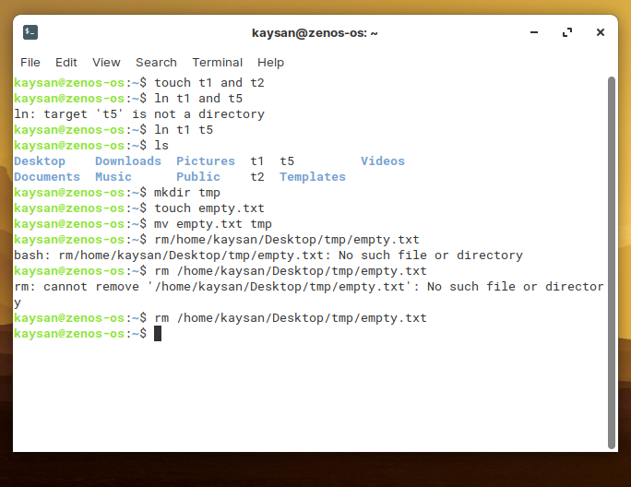

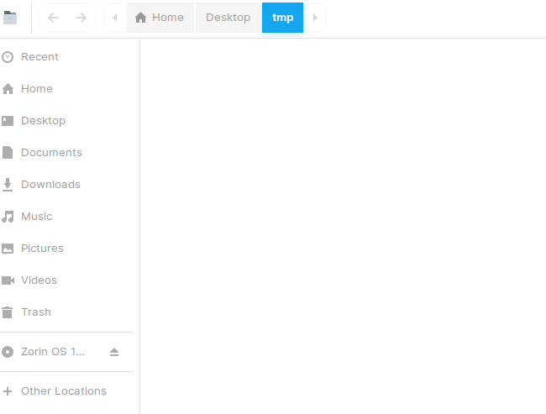

g) Find the location of ls, ps, bash commands.

**Using which Command**

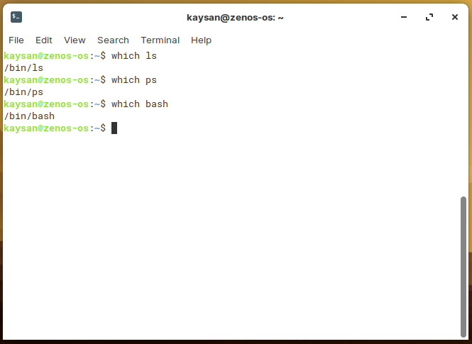

**Using whereis Command**

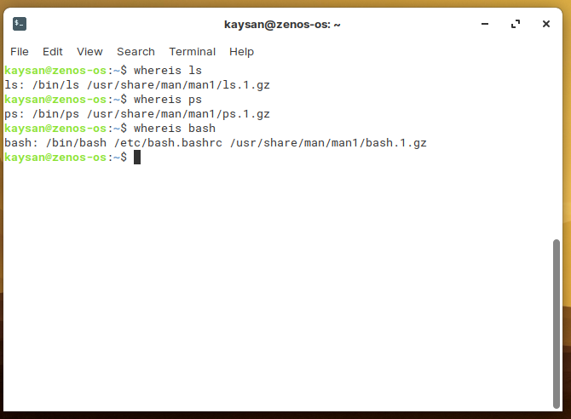

Practical No:06

**Aim:** File Operations.

a) Explore mounted filesystems on your system.

**Using findmnt command.**

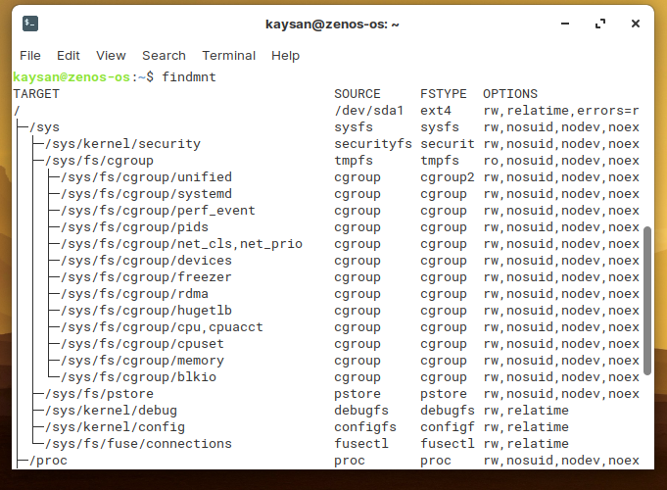

b) What are the different ways of exploring mounted filesystem on Linux?

**Finding mounted filesystem type by using blkid command.**

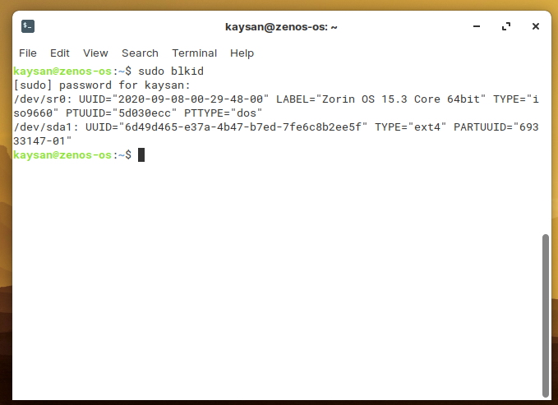

**Finding mounted filesystem type by using df command.**

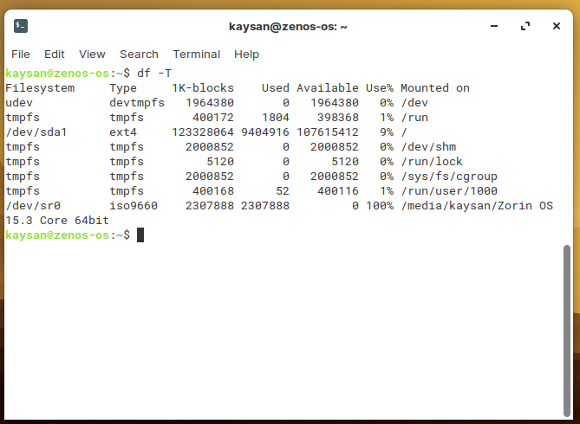

**Finding mounted filesystem type by using lsblk command.**

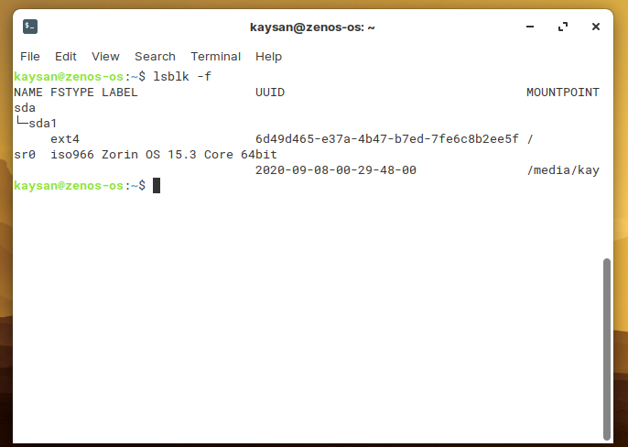

c) Archive and backup your home directory or work directory using tar, gzip commands.

**Using tar command.**

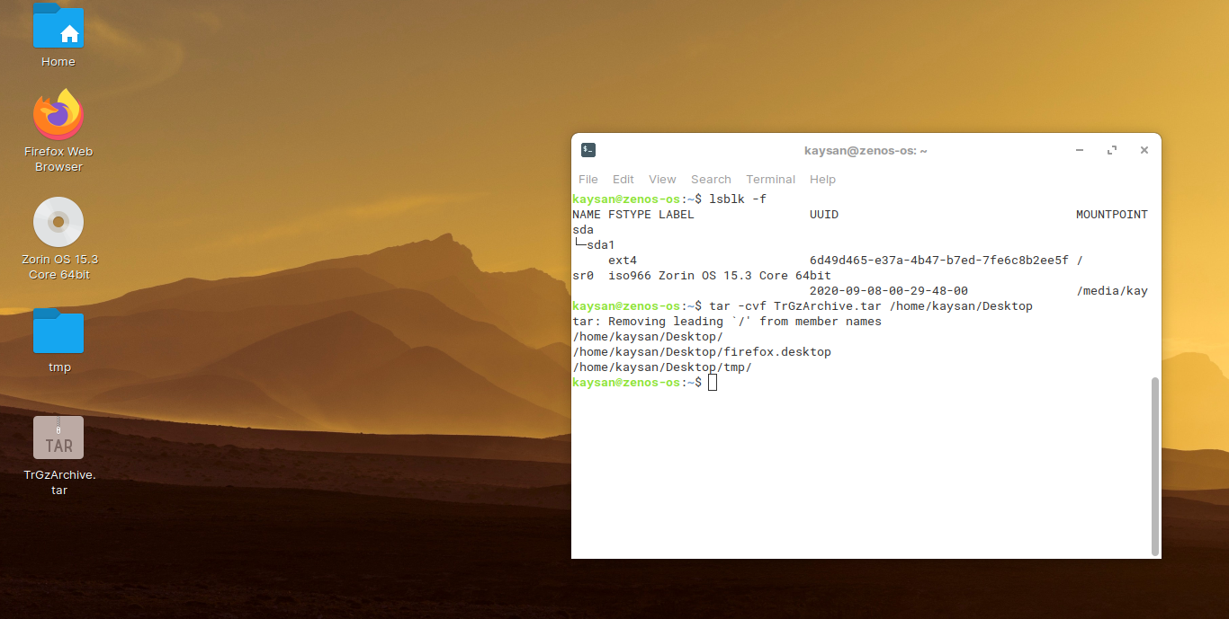

**Using gzip command to compress.**

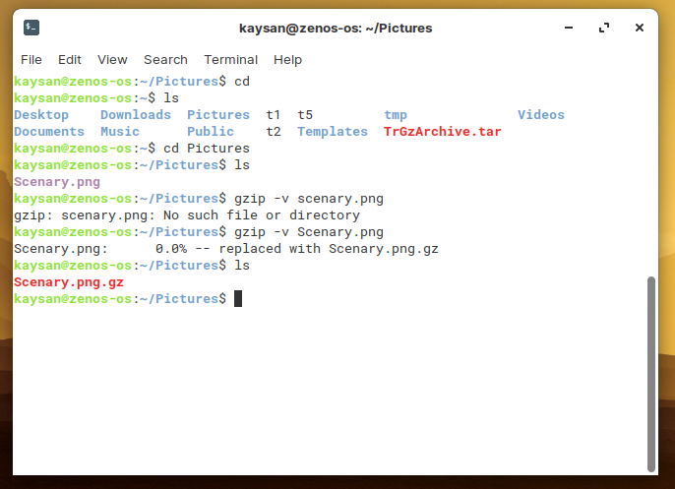

**Zipped file can be created using zip command**.

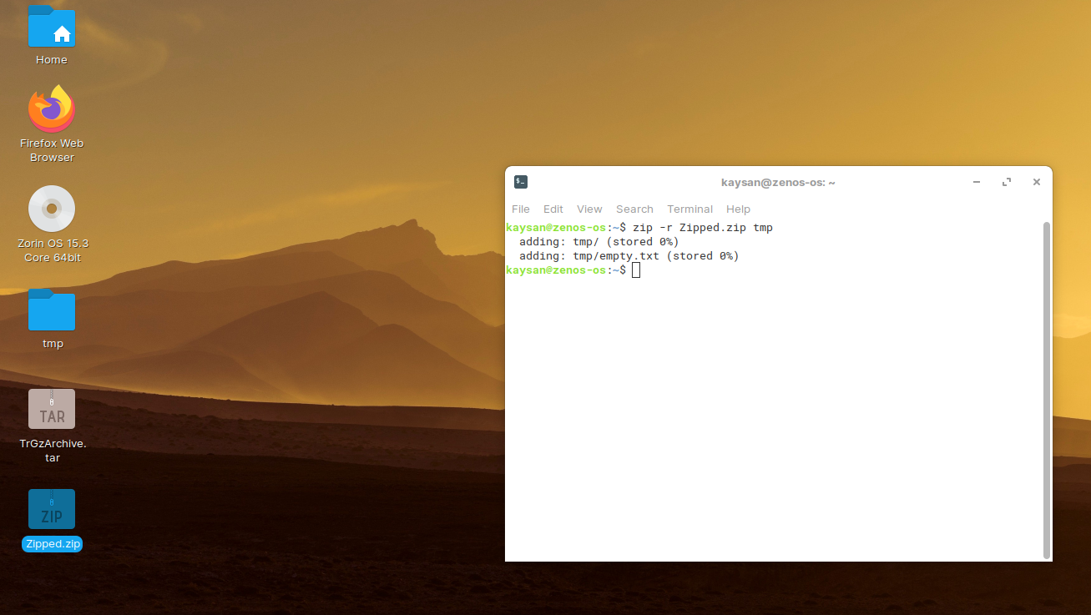

d) Use dd command to create files and explore different options to dd.

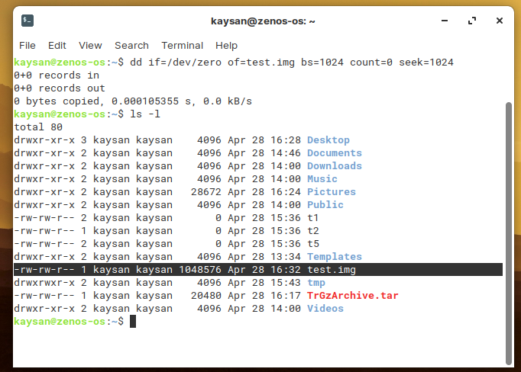

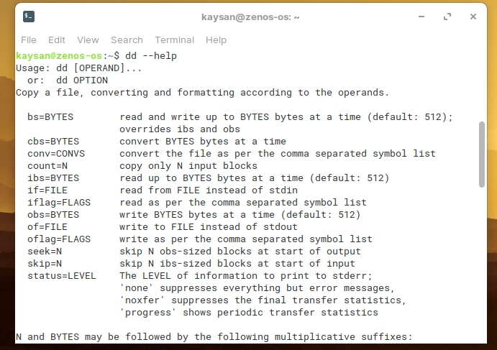

Practical No:07

**Aim:** Use Environment.

a) Which account are you logged in? How do you find out?

**Using GUI**

**Go to settings, search Users and click on ‘Users’.**

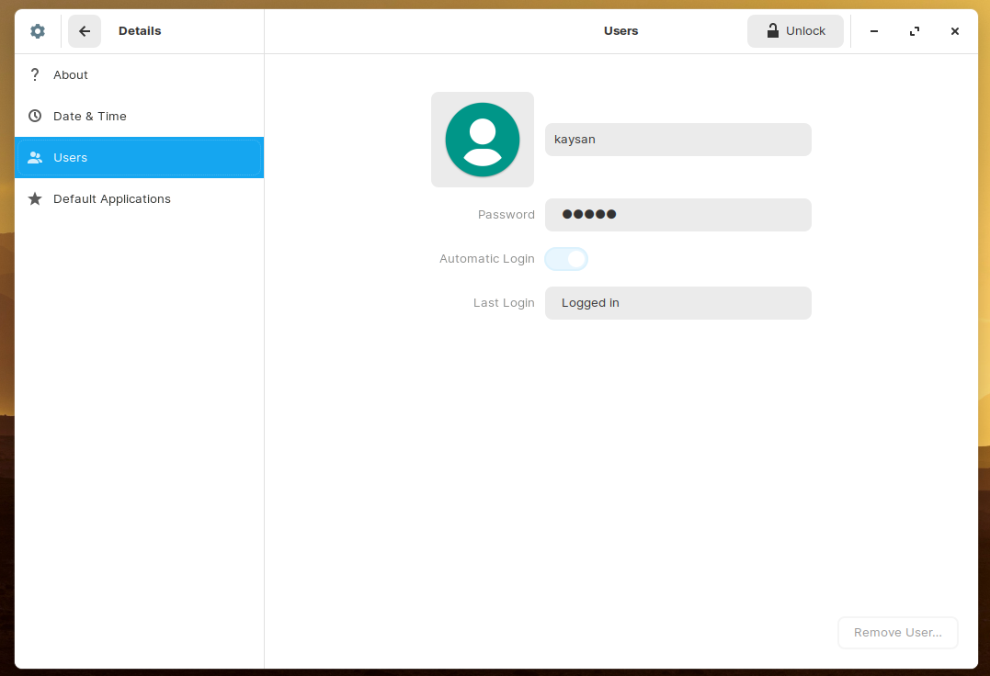

**Using Terminal**

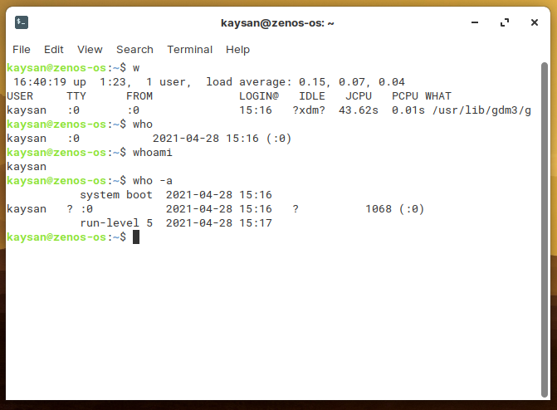

b. Display /etc/shadow file using cat and understand the importance of shadow file. How it’s different than passwd file.

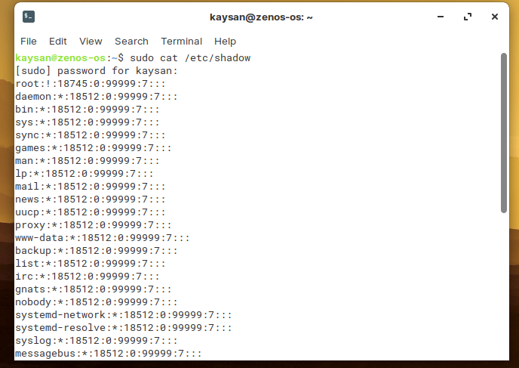

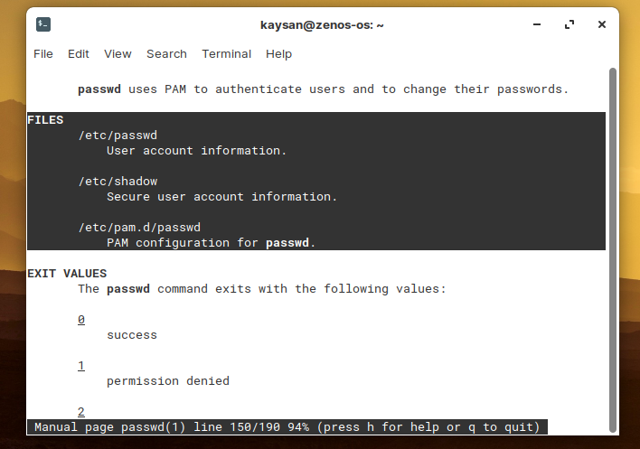

c. Get you current working directory.

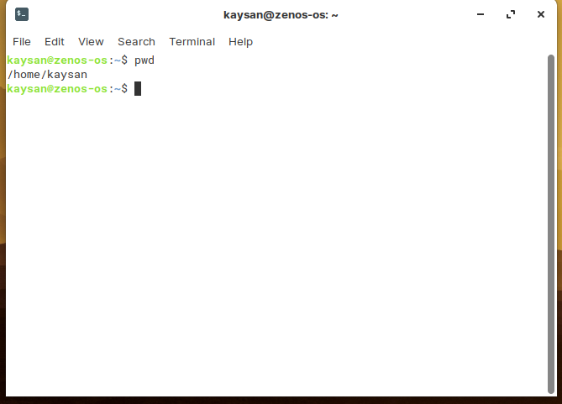

d. Explore different ways of getting command history, how to run previously executed command without typing it?

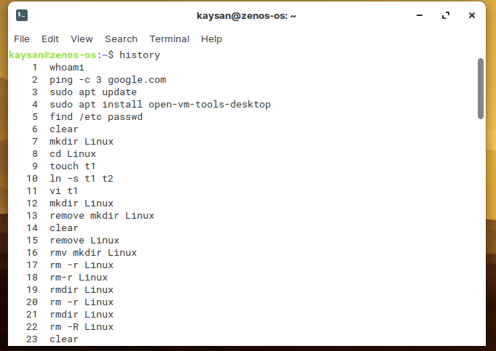

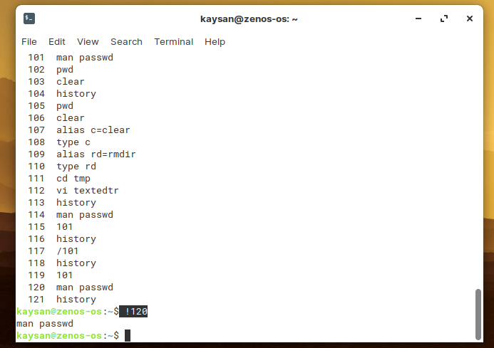

**To run a previously executed command without typing, we can press the upper arrow button to navigate and hit Enter button.**

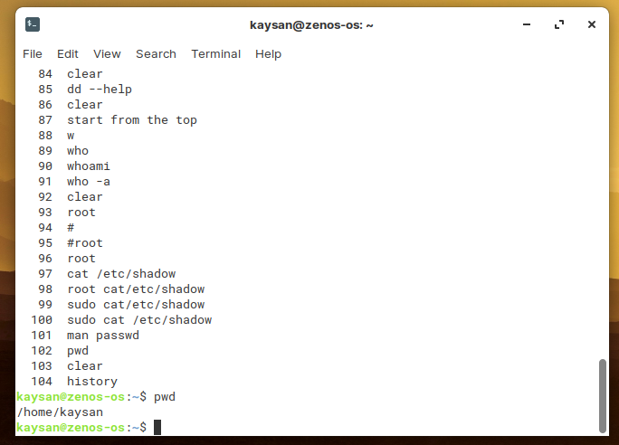

e) Create alias to most commonly used commands like.

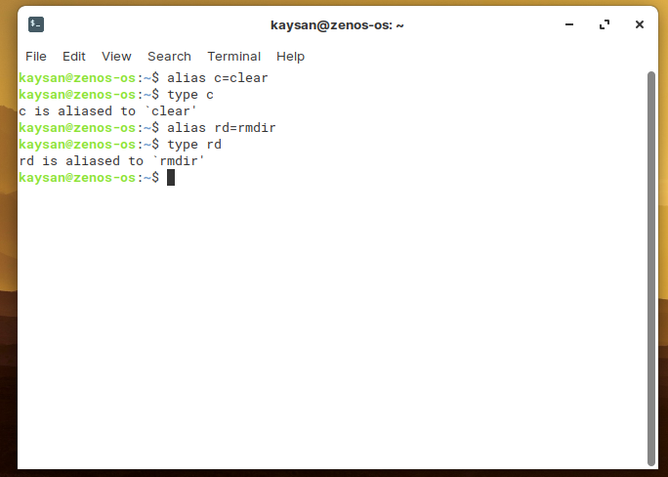

Practical No:08

**Aim:** Linux Editors: vim/gedit/nano

1. Create, modify, search, navigate a file in editor,

**Creating a file in vi editor:**

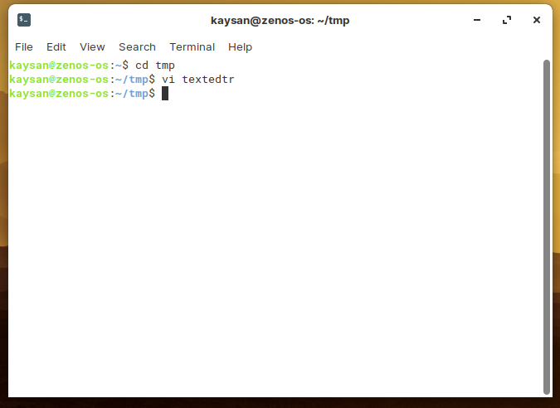

**Modification**

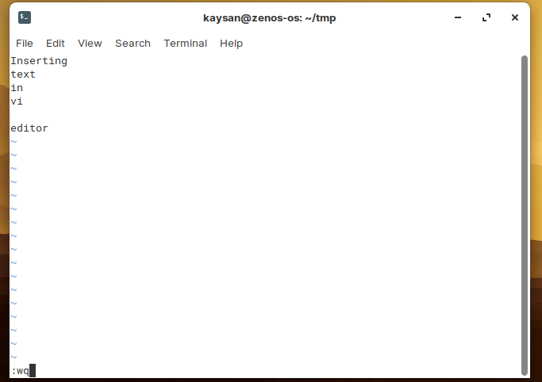

**~ represents an empty line.**

**To insert text, press ‘i’ button.**

**esc + :wq to save and exit.**

**To Search**

**Press esc + ? followed by characters or words for backword search and esc + / for forward search.**

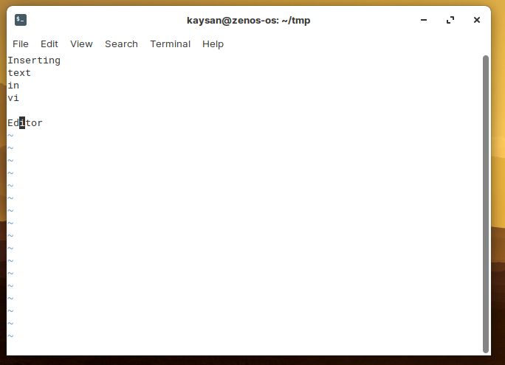

**For more than one occurrence, press ‘n’ to jump to the next occurrence.**

**Navigation**

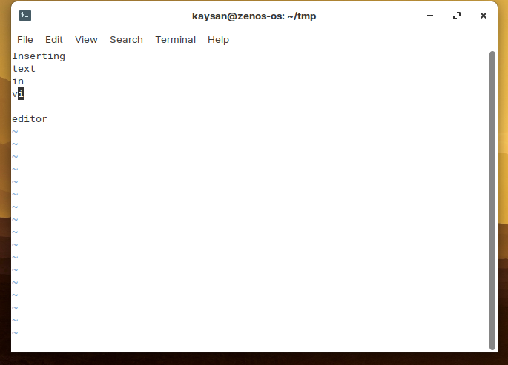

**Press Esc + h to move left in a line,**

**Press Esc + l to move right in a line,**

**Press Esc + j to move a line upward,**

**Press Esc + k to move to the next line.**

b) Learn all essential commands like search, search/replace, highlight, show line numbers.

**Search**

**Select the find option and type the keyword you wanted to search for e.g. I search ‘Kaysan’.**

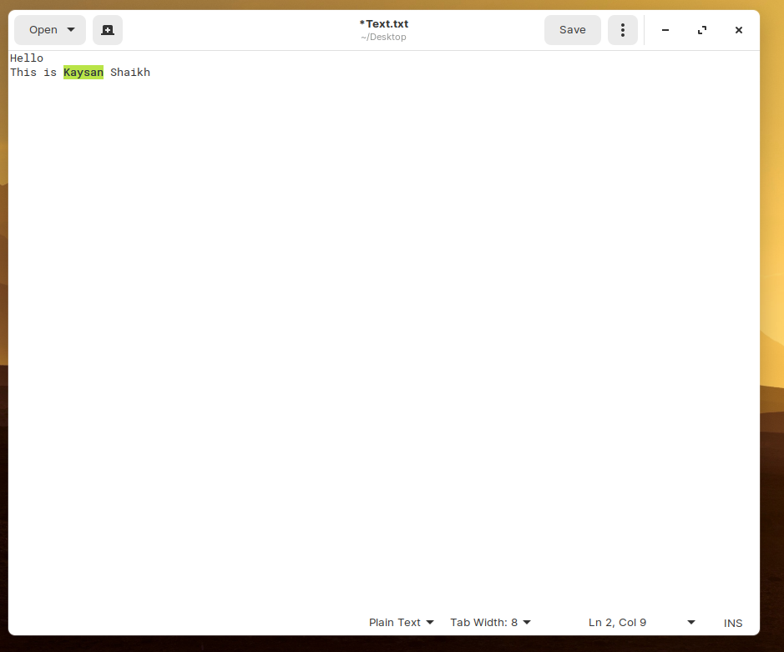

**Search/Replace**

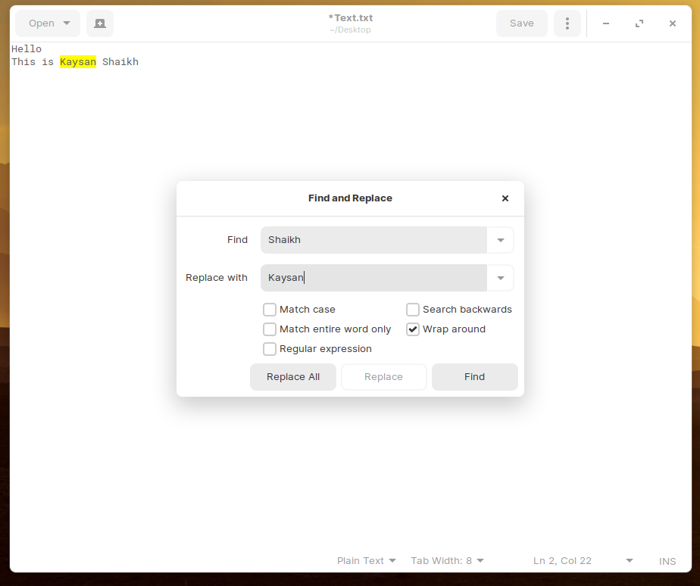

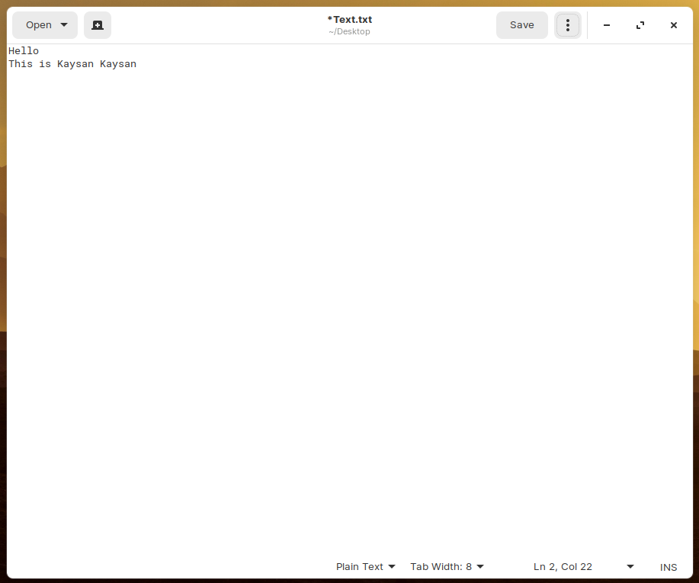

**Highlight**

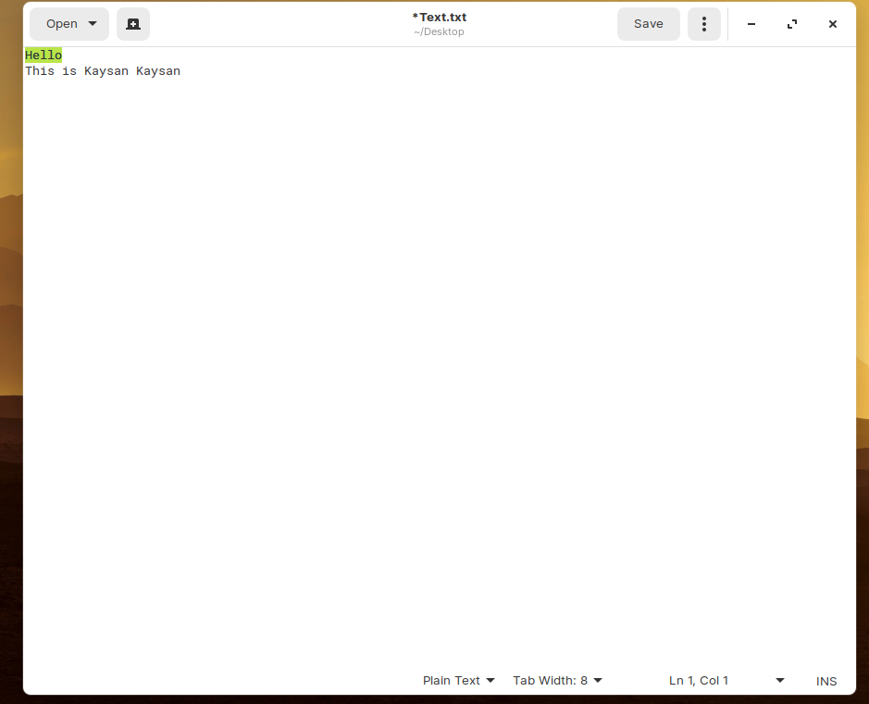

**Show line numbers**

**Go to preference and select display line Numbers.**

